Personal Leadership Development Plan

Cassidy Freeman

University of Mary

NUR 614

Dr. Joanne Lassiter

December 10, 2023

Personal Leadership Development Plan

Leadership is something that may come naturally to some individuals while some must put forth some effort to be a good leader. Becoming skilled in leadership requires commitment to mastering competencies and actively seeking opportunities for growth. This paper explores the leadership competencies I strive to master along with a leadership evaluation fulfilled by coworkers who witness my leadership abilities as a staff nurse. A leadership self-reflection process follows and leads to a professional development plan with my goals and philosophy for my future in leadership.

**Leadership Competency**

The National Organization of Nurse Practitioner Faculties (NONPF) describes that the nurse practitioner demonstrates organizational and systems leadership to improve healthcare outcomes. It also states that “the nurse practitioner participates in professional and personal growth activities to develop a sustainable progression toward professional and interpersonal maturity, improved resilience, and robust leadership capacity. To do this, the following competencies have been identified by NONPF.

The first competency listed includes demonstrating a commitment to personal health and well-being. This can be done by creating an environment that promotes self-care, health, and well-being as well as supporting the whole person’s health and holistic well-being of self. The second competency listed includes demonstrating professional maturity. This can be done by demonstrating responsibility to practice in the NP population focus area. Another way to complete the second competency is by employing empathy to communicate effectively, conducting self in a professional manner, and upholding standards of the NP profession. The third competency is to develop capacity for leadership. This can be done by articulating the complex leadership role of the NP, execute leadership skills in the translation of new knowledge to improve outcomes.

**360 Evaluation: Leadership Evaluation Tool**

The purpose of the leadership evaluation was to gather information on my current abilities and performance to reflect and develop a plan for success in my future leadership development. I chose to use the nursing leadership evaluation tool that was in the syllabus. I chose this tool as it efficiently and effectively lays out qualities every leader should have. This evaluation tool has instructions at the top that explain the purpose of the evaluation for the evaluator. There are 17 statements made in this evaluation tool that the evaluator must answer. Questions addressed leadership qualities such as accountability, decision making ability, people skills, planning management, and ability to resolve conflict. The questions in this tool are applicable to the leadership competencies in the NONPF. This evaluation allowed responders to rank answers from 5 (almost always) to 1 (never). There was also an option for responders to choose not applicable or don’t know. can do less of.” Qualitative data was also gathered in three open-response questions focused on strengths and weaknesses with a section for additional comments. Evaluators included my manager, my direct supervisor, and a coworker to obtain well-rounded results.

**Method of Confidentiality**

To de-identify the evaluations, I had each evaluator send the evaluations to Nicole Davidson. Nicole is a coworker that I work with, and she is not one of the individuals that I chose to complete the evaluation. She went through each evaluation and ensured no identifying information was found. She then emailed them to my university email account. I also spoke with each evaluator to explain how the process for maintaining confidentiality was going to work.

**Leadership Evaluation**

Overall, the results from the survey were positive. The mean score of the evaluation questions were calculated to reflect the overall feedback ratings. A full list of questions and mean score can be found in Appendix A. Two of the questions got a 5/5 while six questions received either a 4.67/5 or 4.3/5. The majority at five questions received a 4/5. One question did receive a mean score of a 3/5. Three questions did receive a N/A. The questions that received a 5/5 included words like “quality of care” and “considerate, patient, and helpful.” I was not surprised at the three results that received a N/A due to my current job not being in a leadership role. The questions that received a N/A included question number 7, 8, and 11 (see appendix A).

**Leadership Evaluation Reflection**

This leadership evaluation survey has allowed me insight to how others perceive me as a leader. Initially I was shocked at the results of the survey. I did not think I would receive very many 4’s or 5’s and for the most part, the mean was in-between 4 and 5. It was reassuring to see the results of the survey as I had a supervisor, coworker, and preceptor fill out the surveys. I will use the results of this survey to strengthen my leadership skills. For example, when reflecting on question number 12 (see appendix A) I have started to think of ways I can prevent high-impact staff departures in my current position as a staff nurse. I would have liked to have more evaluator comments, however, the evaluator comments I did have made my confidence increase as an employee and as a leader.

**Self-Assessment**

To assess my own leadership skills, I completed the same evaluation that I had the evaluators complete. By completing this, I realized I rated myself harsher than my evaluators. See appendix B for the answers to my self evaluation. For example, I did not give myself a 5/5 on any of the questions whereas my evaluators did. The average answer I gave myself was a 3/5. The reasoning behind why I gave myself a 3/5 is because I believe that there are many ways in which I can improve on in those questions. I also do not have a ton of experience in those areas, so I did not feel confident in giving them a higher rating. After comparing the evaluators evaluation with my own, I realize I need to be more confident in myself and my skills as a leader. I do think that there are times that I can be a little too humble and instead to embrace myself and know that others do view me as a good leader.

**Professional Development Plan**

Having a knowledge of what my current strengths and weaknesses as a leader is beneficial in planning for future growth. I have also completed three leadership assessment tools that allowed me to gain insight on who I am as a leader and how my leadership style effects my decision making and communication with others. I was able to learn how my personality traits and emotions tie into the type of leader I am. Below I will outline action plans that incorporate my leadership traits and areas I can improve on.

One area I plan to focus effort on is becoming more versed in all the processes that make up my organization. I do not currently hold a leadership position, so I am unfamiliar with the finances of the organization, as well as thinking of the department from a long-term perspective. One way I plan on doing this is by becoming more involved in the current department I am working in. One way to become more involved would be by joining the unit-based council. Unit based council meets once per month and they discuss the inner workings of the department. This includes financial issues the department is having as well as how the department can improve in the future.

Conflict management and communication are other leadership skills I intend to improve on in the future. My leadership personality is that of an adventurer which means that I like to be independent (16personalities, n.d.). Offering criticism or feedback during conflict makes me uncomfortable which in turn causes communication to lack. In the future, being aware that I do not like conflict can allow me to pay attention internally if confrontation or communication is needed. Conflict management is one skill that is imperative to be a successful leader, so it is something that can continually be improved.

As I mentioned before, one area I can improve on is preventing high-impact staff departures in my current position as a staff nurse. One way to do this, would be by improving staff morale and spreading positivity. Emotions are contagious and negative emotions tend to spread more quickly than positive emotions. If negative emotions are allowed to spread through a workplace, there may be a negative effect on morale, productivity, and motivation (Neck et al., 2019). Moving forward, I will be more aware of my own emotions and how they may be affecting others. I plan on being more present and participate in employee engagement to help connect with employees in a positive environment. The current unit I am working on has a retention and recruitment committee or R&R as we like to call it. The R&R committee has events once a month that are away from the hospital. This summer they included going to our local semi-pro league baseball team and produce picking at a local farm. When I took the personal preference profile assessment, the results showed that I am dreamer minstrel. This described people like me having positive optimism, empathy, and always being able to find the silver lining (Kingdomality, n.d.). I would say this does describe me to a T. However, I have noticed that while at work I can be negative and may not always show empathy. So, by separating myself from work with my coworkers, I will be able to bond more with them and they can also get to know me as a person outside of the hospital.

Working in the ICU can be very stressful, and stress does not always bring out the best in people. One way I can help minimize the stress would be to engage in activities that are stress reducing. For me, I have recently started going to a yin yoga class. This class focuses on relaxation and mindfulness. Since going to this class, I have noticed that when situations get stressful at work, I can use some of the techniques I have learned in this class to help my mind stay stress free. Without having as much stress in my mind, I can communicate better with my coworkers along with the providers I work with.

**Future Leader Description**

Since I have only been at this unit for about 10 months, I believe that others see me as a new leader that is growing into their role. I also think that others know that I am dedicated to fostering teamwork. I always make the conscious effort to be kind and assist others. In five years, I hope people see me as an established leader who is confident in her ability and confident in the abilities of her team. I want to be a leader that everyone is comfortable coming to with issues and the person that people can look up to. I hope that I will be the example of professionalism and living the mission and values of my organization.

**Philosophy of Leadership**

Servant leadership focuses on the growth and well-being of others and therefore plays a major role in my personal philosophy of leadership. The characteristics of stewardship is the true meaning of being a leader. Stewardship is being committed to the greater good of others. Within leadership, stewardship involves a commitment to growth of people and nurturing personal and professional development (Neville et al., 2021). I believe that leaders should continually work at improving themselves so they can continually motivate others to improve.

Transformational leadership requires caring leadership behaviors in order to facilitate individuals to create and improve systems. Transformational leaders must foster environments that allow individuals to contribute to their fullest potential instead of forcing change through traditional assertion of control (Albert et al., 2020). Trusting in the ability of others is one leadership quality that I believe must be used in transformational leadership. Personal integrity is also imperative for leaders who inspire to transform. Being seen as a great leader is the only way the minds and actions of others will be changed by your influence.

**Conclusion**

Leadership is much more complex than being the person in charge of a group of people. To be a great leader, there must be thorough commitment and high level of self-understanding. Conducting a leadership evaluation tool along with various leadership assessments has allowed me to see the full picture of where I stand as a leader today. By reflecting on the leadership evaluation tool and leadership assessments, I was able to form a plan to become a better leader in the future. There are many skills that encompass leadership, and I will spend the rest of my career being committed to mastering them.

References

16Personalities. (n.d.). Workplace habits. <https://www.16personalities.com/infps-at-work>

Albert, N. M., Pappas, S., Porter-O'Grady, T., & Malloch, K. (2020). Quantum leadership: Creating sustainable value in health care: Creating sustainable value in health care (6th ed.). Jones & Bartlett Learning.

Kingdomality. (n.d.). The dreamer minstrel. <https://kingdomality.com/?s=Dreamer+Minstrel>

National Organization of Nurse Practitioner Faculties. (2022). National organization of nurse practitioner faculties’ nurse practitioner role core competencies. <https://www.nonpf.org/page/14>

Neck, C. P., Houghton, J. D., & Murray, E. L. (2019). Organizational behavior: A skill-building approach (2nd ed.). SAGE Publications, Inc.

Neville, K., Conway, K., Maglione, J., Connolly, K. A., Foley, M., & Re, S. (2021). Understanding servant leadership in nursing: A concept analysis. International Journal for Human Caring, 25(1), 22–29. <https://doi.org/10.20467/humancaring-d-20-00022>

Appendix A

**Nursing Leadership Evaluation Tool**

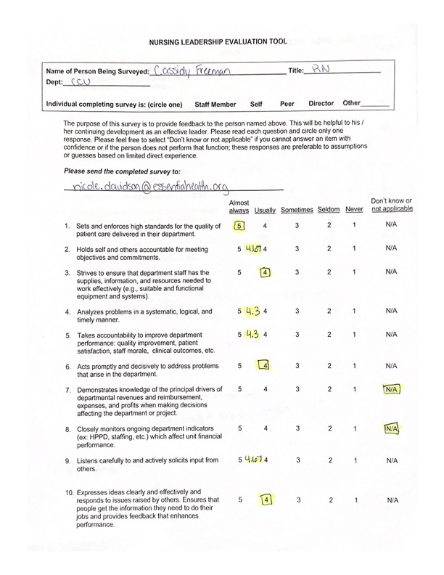

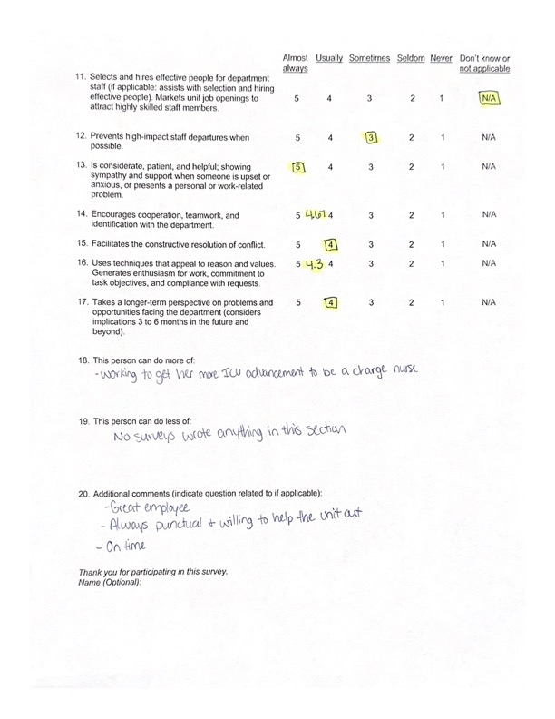

Appendix B

Self Evaluation

